Secure Programming 3rd Year Project

By Pixie B00159841 , Sena B00159349 & Brandon B00165015

# Brandon:

## Known Vulnerability

### Brute-Force Attack

In apps.py the section of code for the login queries the user to enter their username and password and checks it against the database but it does not stop users from brute-forcing as it allows them to make as many attempts as they want and it doesn’t give them a cooldown between attempts. This makes brute-forcing quick and easy

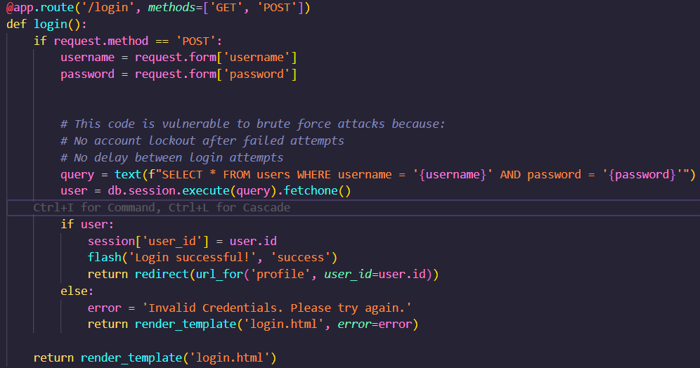

As you can see below, I wrote a basic function to brute force attack it, you can see the full code on our git repository but this shows the function and below that image is it succeeding when ran

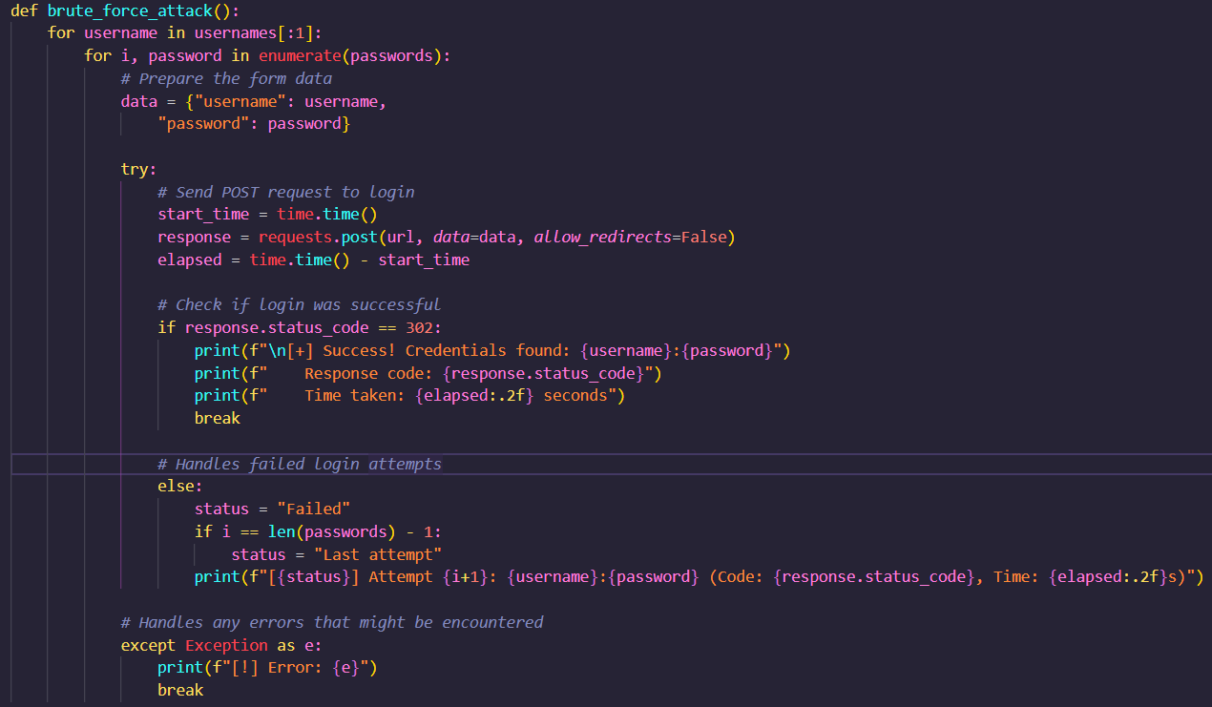

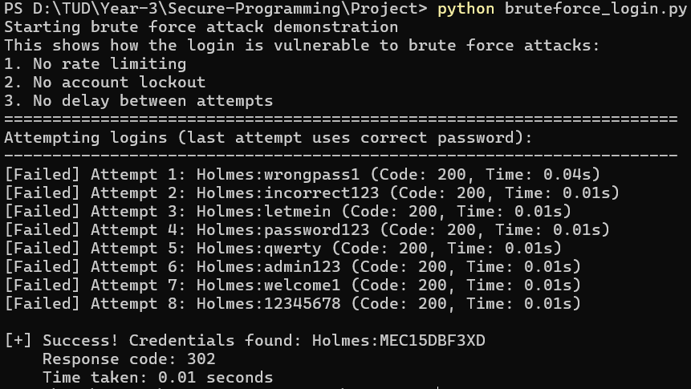

That lack of delay is a big problem as you can see how quickly this succeeded, now I did have know the usernames and passwords and only set a few fake ones but a delay would have made that taken longer.

To stop this, I added a list called failed_attempts locally, though a more secure approach would probably be needed on a real webapp. I then I call on that list within the login function in app.py. This works by using the ip variable to get each new failed request to login and store it in the list. It then checks for how many attempts, if it’s the third attempt checks, if the last attempt made has been over 10 minutes since the first using current_time. Photos in order of explanation instead of code.

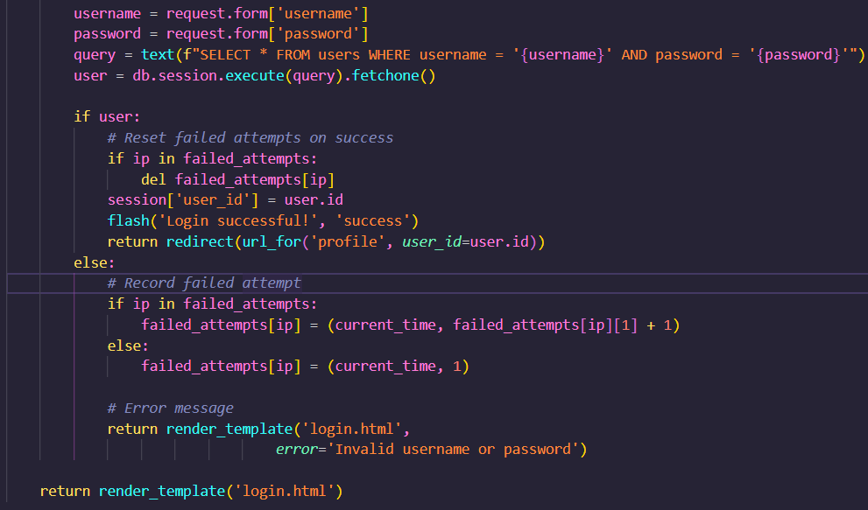

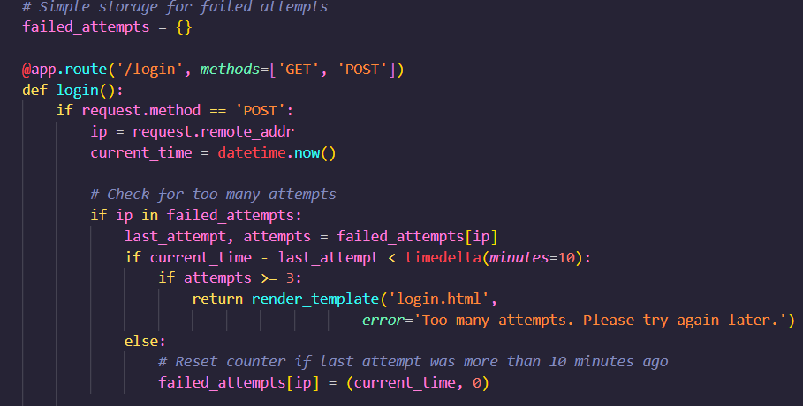

When running my brute_force script you can see it no longer succeeds as by the time it attempts the right password, it has been timed out for 10 minutes.

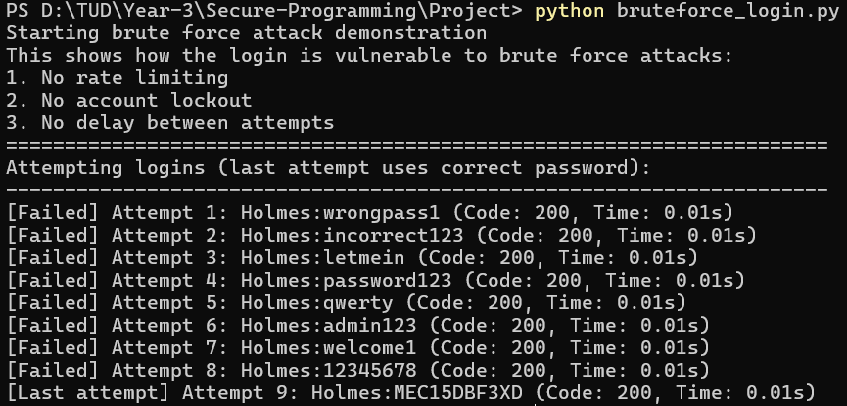

## Unknown Vulnerabilities

### Server-Side Request Forgery

In the apps.py the redirect function allows users to access they want by just adding it to the the url. A threat actor could figure out info on the database, web service and other server side processes by using known ports.

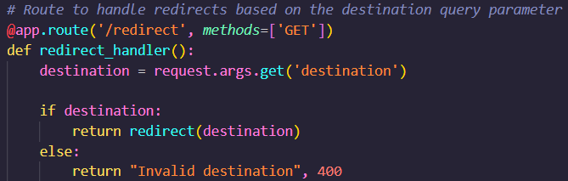

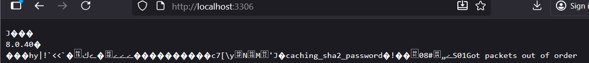

I got the version of MySQL here but it blocked the connection for the most part but shows it is vulnerable.  
  
To fix this, we should whitelist the allowed pages for redirect so that it’s only our public pages we want users to see.

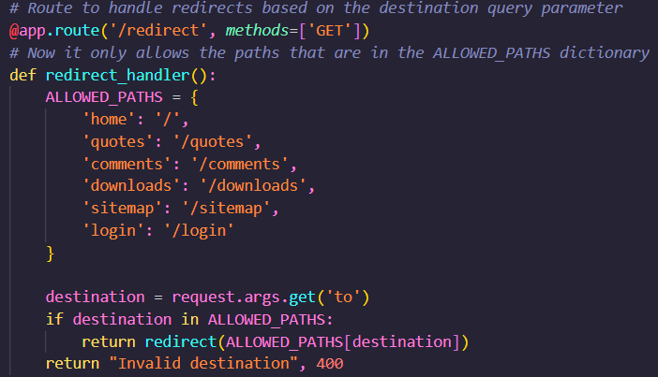

All I have done is add a dictionary of allowed pages and then added a check to make sure the page they are trying to go to is in our allowed paths. As you can see the same URL now gives ZERO info.

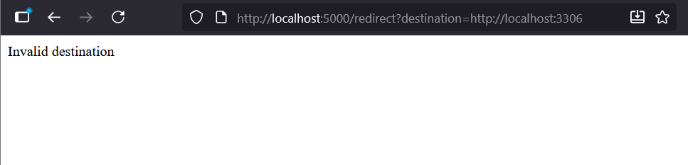

### Denial of Service (DoS)

Not 100% on this one but I noticed you can download the files and it got me thinking of DoS attacks so I made a simple script to download the file indefinitely on multiple threads, I went a little hectic in the end as it took a lot more threads than I realized to have any effect on the website but once I just went crazy with 0s it finally did this. The right handside is my python script running in the shell. Below that photo you can see the script I made and it will be on the git. I just mad a function to flood the server with the same download request using a while loop that has each thread immediately close the connection and repeat once response is received. The threads themselves are initiated in the for loop

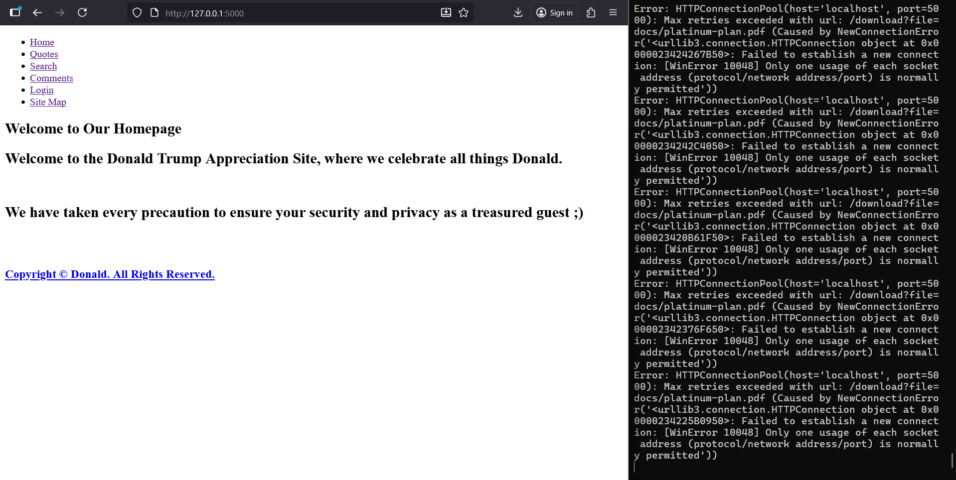

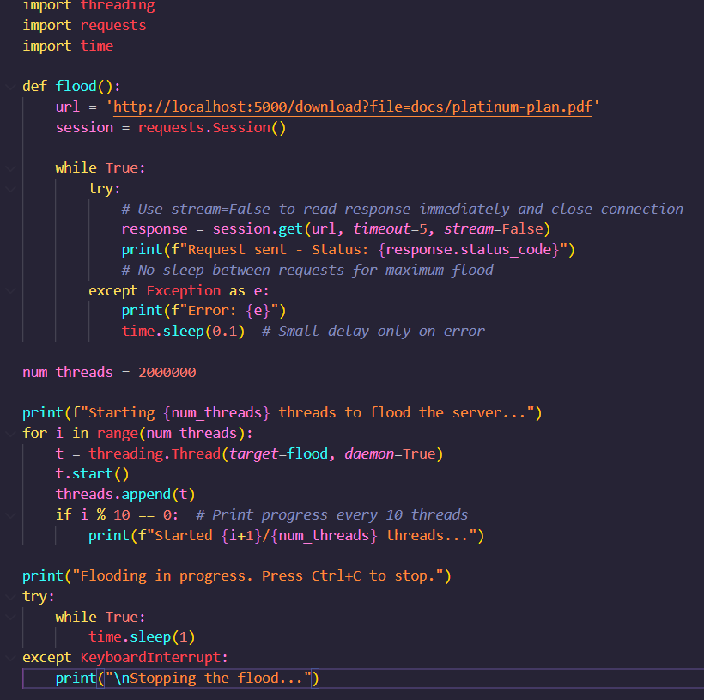

Here is the vulnerable function:

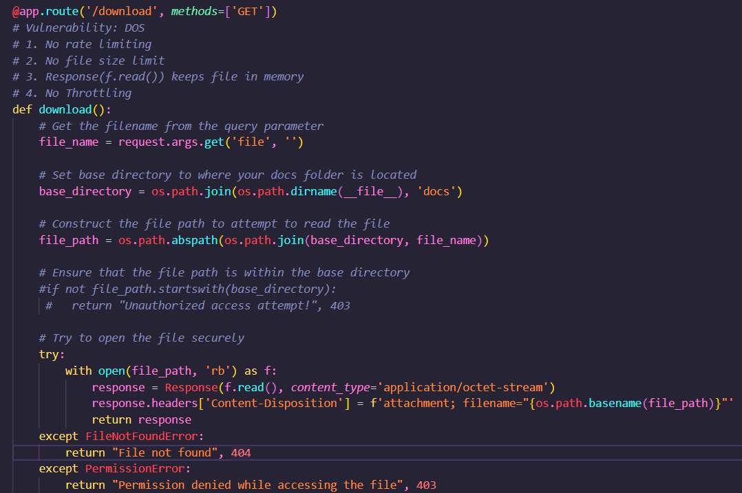

To mitigate this, I added some basic solutions. We limit the rate similar to how we stopped brute force attacks by using a list to store how many times an IP has requested to download a file and current_time as a way to set the counter for cooldowns when limit has been reached. We also make sure the file doesn’t flood server side memory by using send_file. As you can see below the code, when I run my simple DoS.py it now gives a message saying that that “the target machine actively refused it” meaning the server itself started refusing requests as we planned.

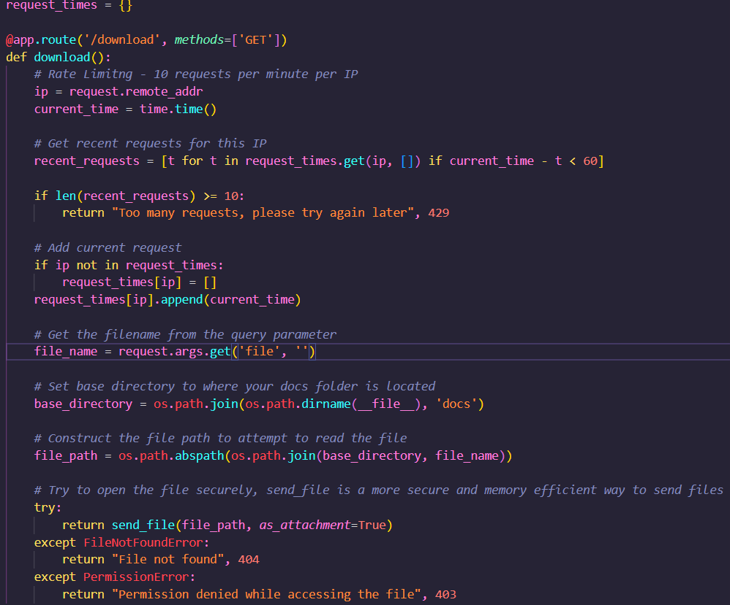

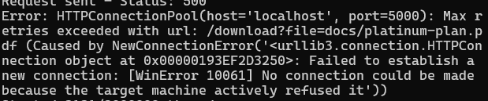

# Sena:

## Known Vulnerability

## Vulnerably 1: XSS

XSS Vulnerability Found in /search route with search.html template.

* Line 129 in app.py: The search route takes user input from the query parameter.
* Line 15 in search.html: The template uses {{ query|safe }} which disables Jinja2's automatic HTML escaping. This allows JavaScript to be injected and executed in the browser.

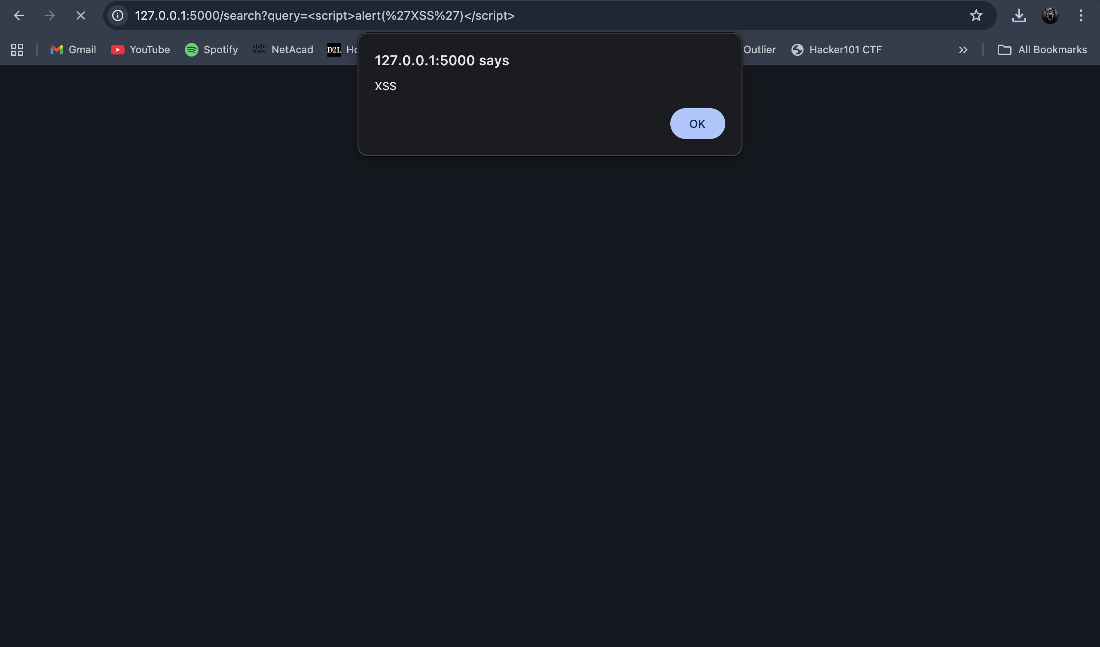

## Vulnerable code:

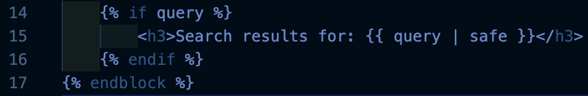

## Exploit:

[http://127.0.0.1:5000/search?query=<script>alert(‘XSS’)</script](http://127.0.0.1:5000/search?query=%3cscript%3ealert('XSS')%3c/script)>

The “|safe” filter in Jinja2 tells the template engine to render the content as it is, without escaping HTML special characters. This means any JavaScript code in the query parameter will be executed in the browser.

## Fix:

Remove the |safe filter to enable automatic HTML escaping:

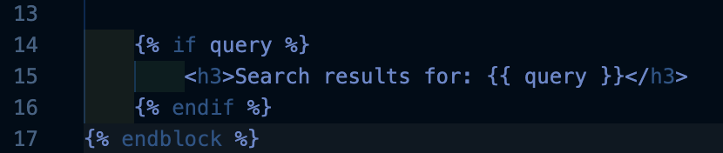

The threat has been fixed XSS is no longer possible.

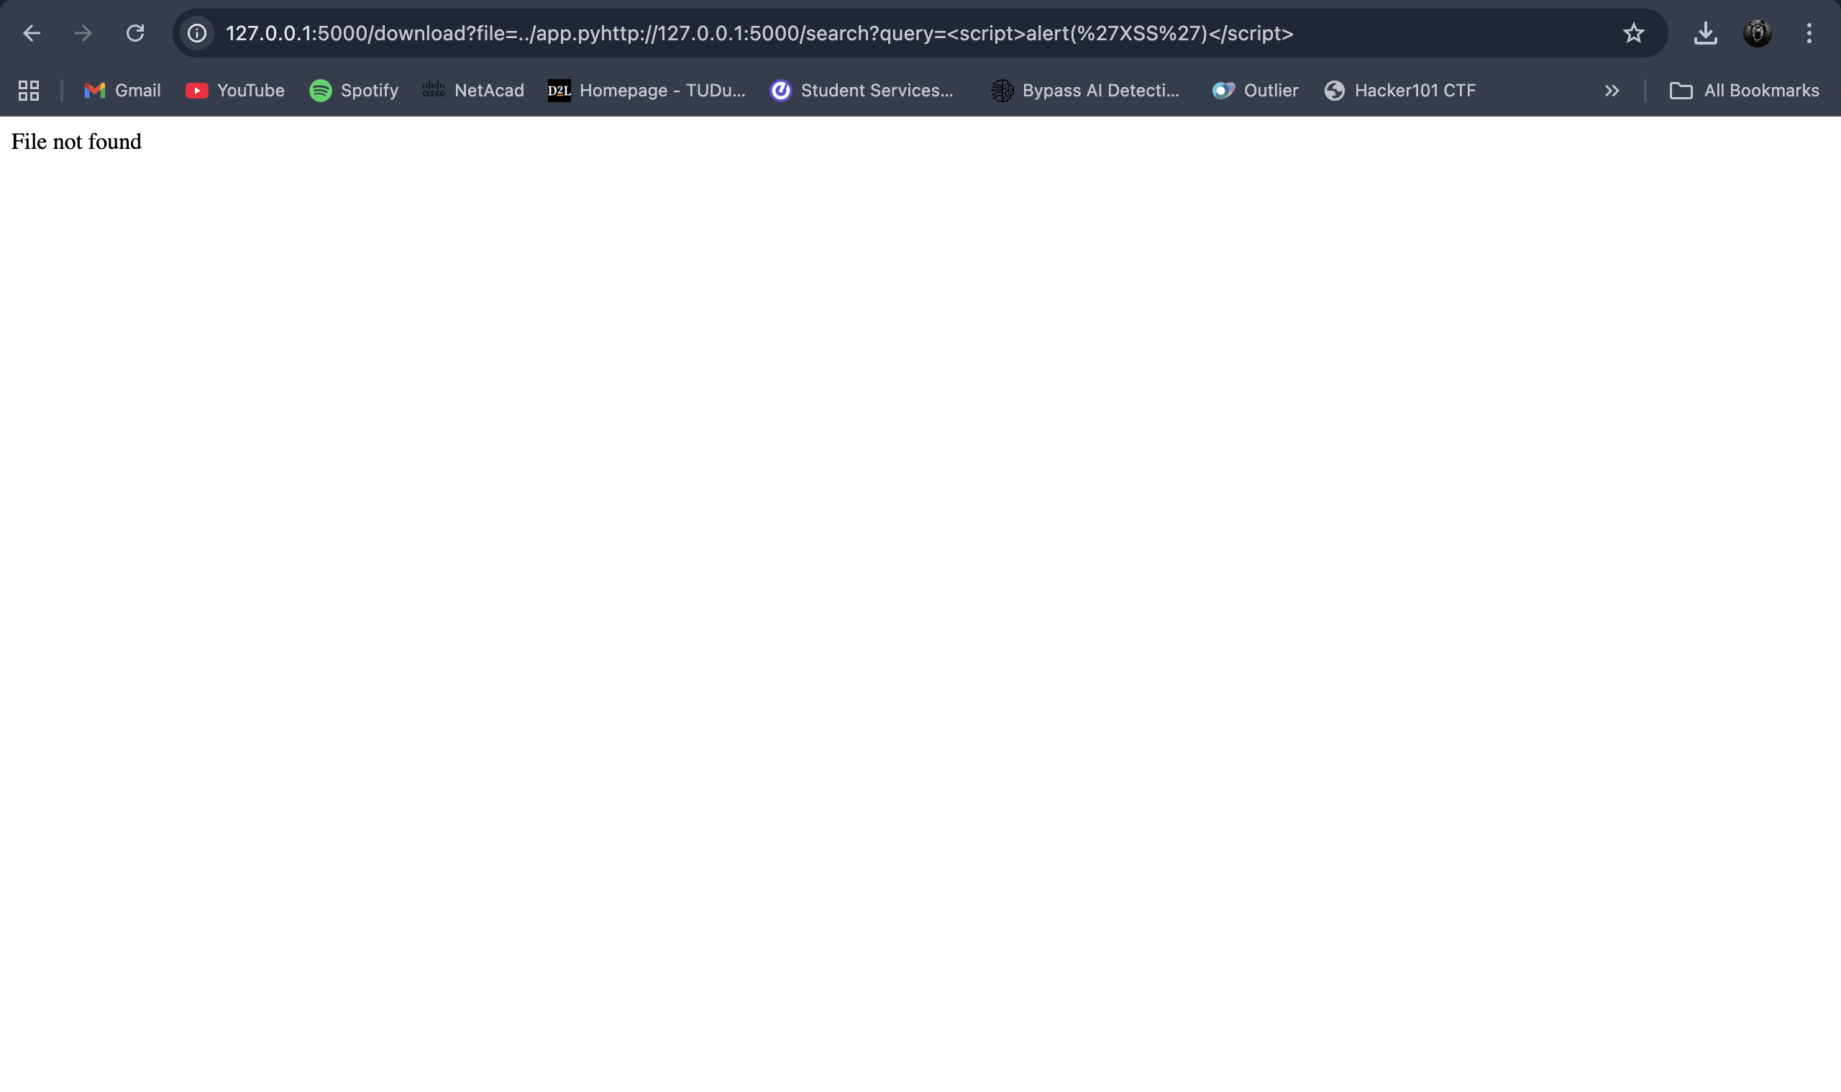

This is a XSS vulnerability usually found in search functionalities where user input is directly reflected back to the page without proper sanitisation.

## Exploit 2: Path Traversal

By manipulating file path references using special character sequences (primarily ../), I was able to read and download important files on the system, this vulnerability can potentially lead to the exposing sensitive data including source code, database, credentials, and system files.

I was able to install the app.py file, the Database file and the SQL file using the ../ sequences.

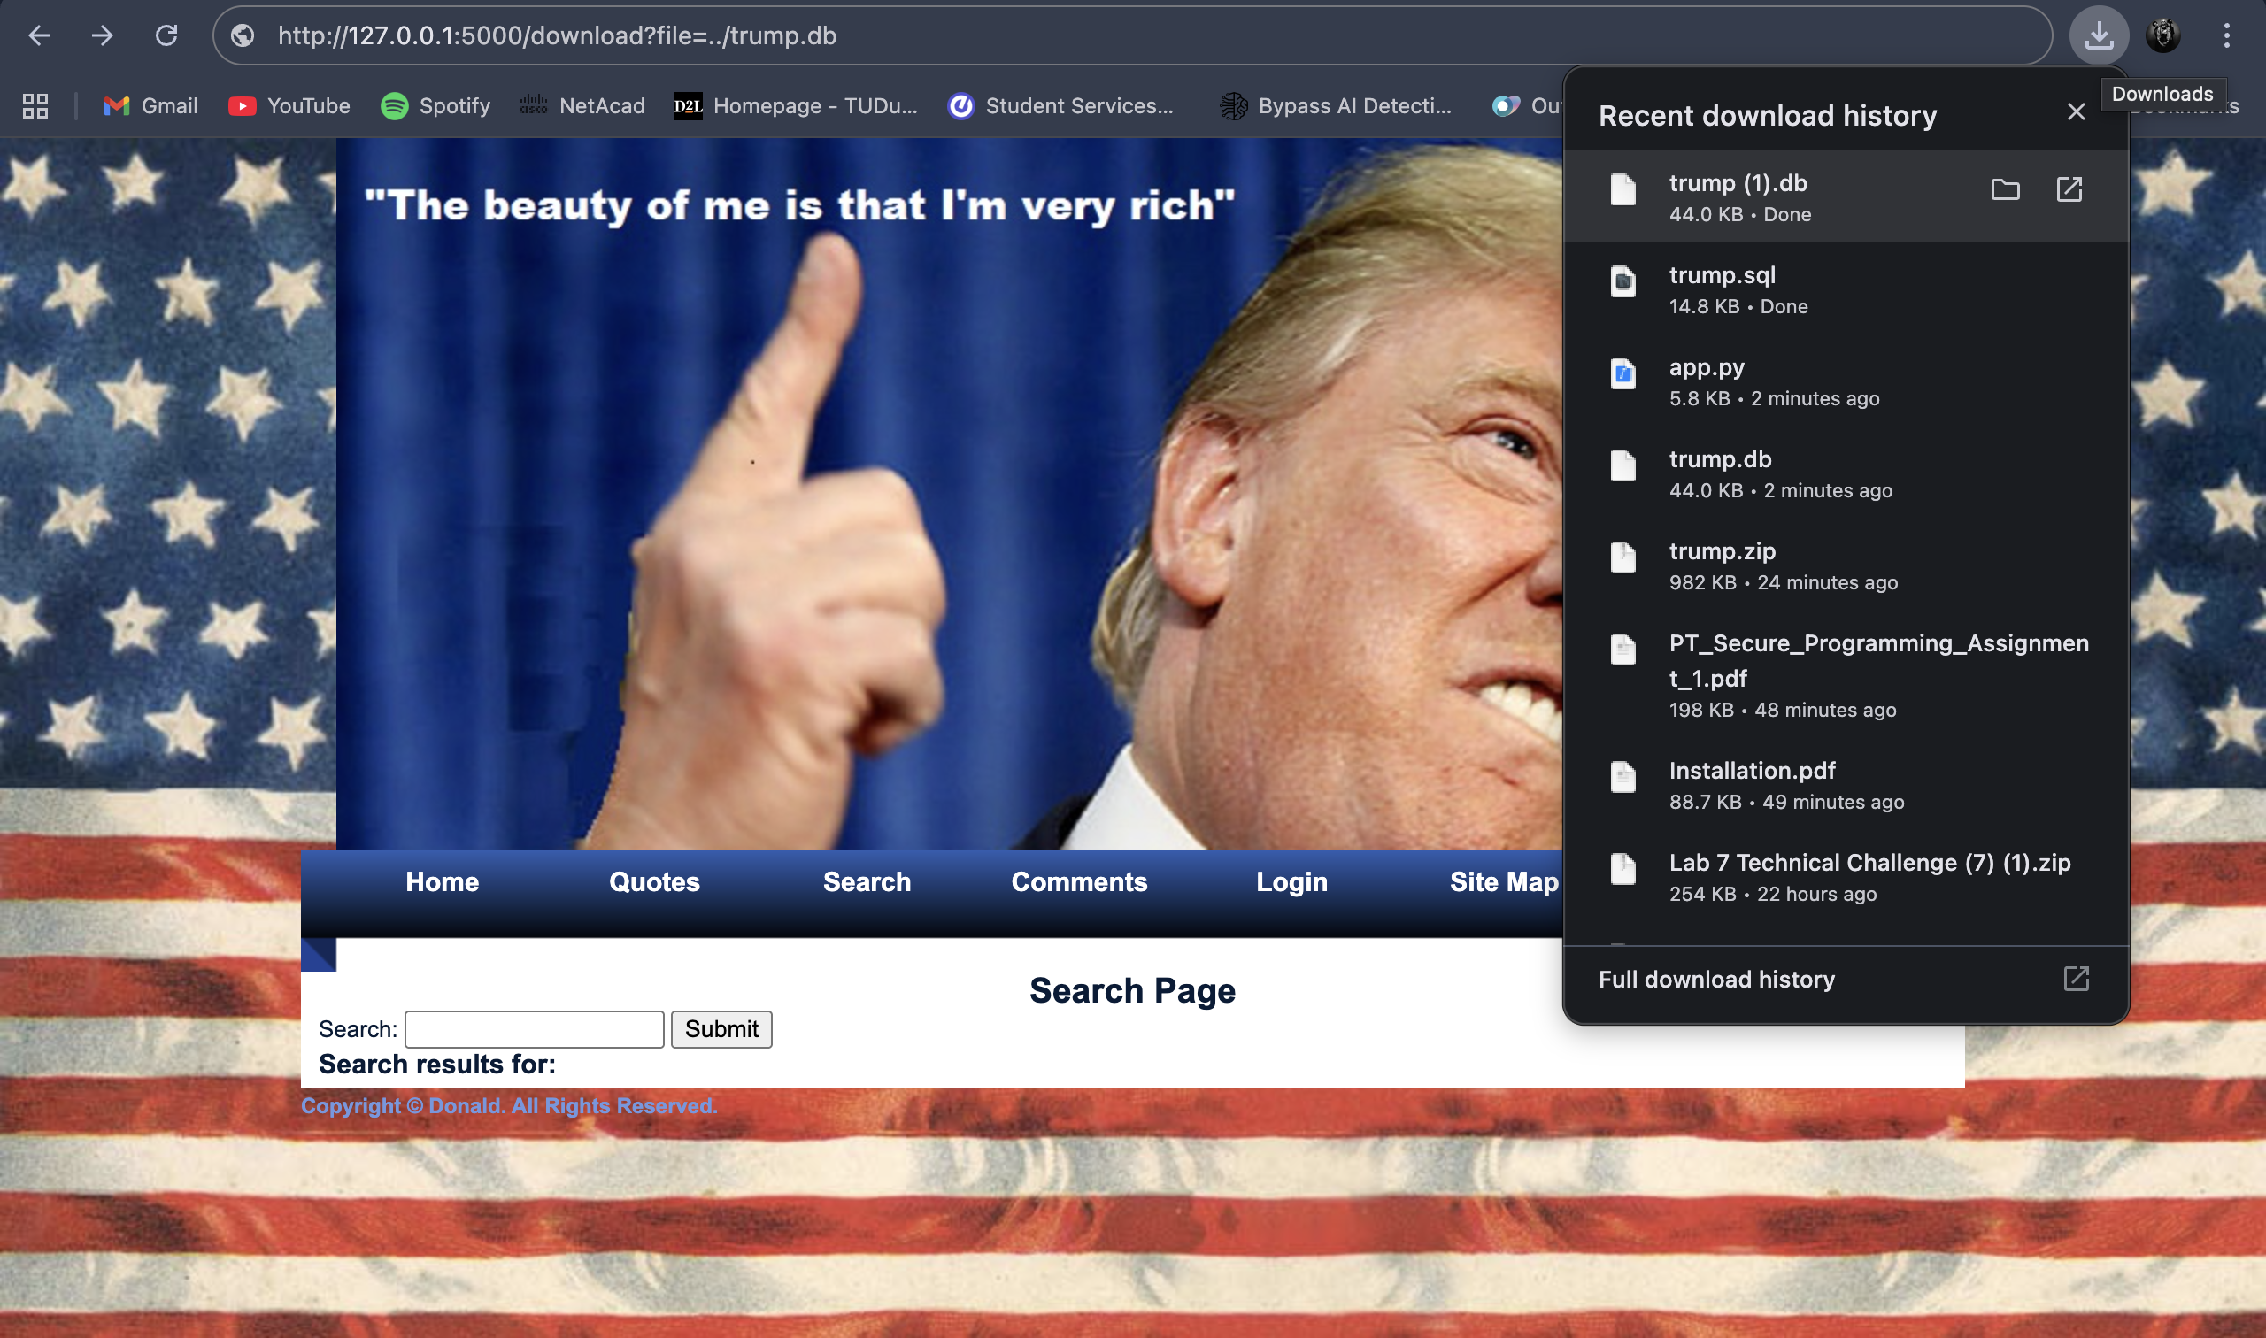

The commands below allowed me gain access to all the files mentioned above:

<http://127.0.0.1:5000/download?file=../trump.db>

<http://127.0.0.1:5000/download?file=../app.py>

http://127.0.0.1:5000/download?file=../trump.sql

## Vulnerable code:

The .. (dot-dot-slash) sequence allows navigation up the directory tree.

Since the security validation on lines 96-98 is commented out, there's no check to ensure the path stays within the intended docs/ directory. With it disabled, I was able to traverse to any location on the filesystem.

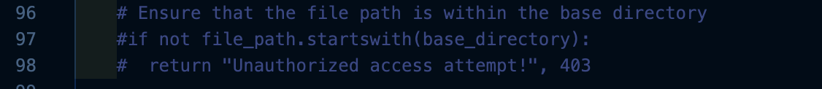

Fix:

Uncomment lines 95-96 to enable the path validation:

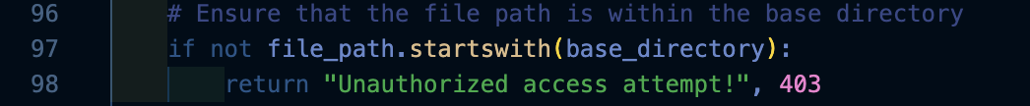

Before**:** Attackers could access any file on the system.

After**:** File access got restricted to docs/ directory only.

Attackers do not have access to the database or the source code from the website using path traversals anymore, the files are restricted to docs/ dir.

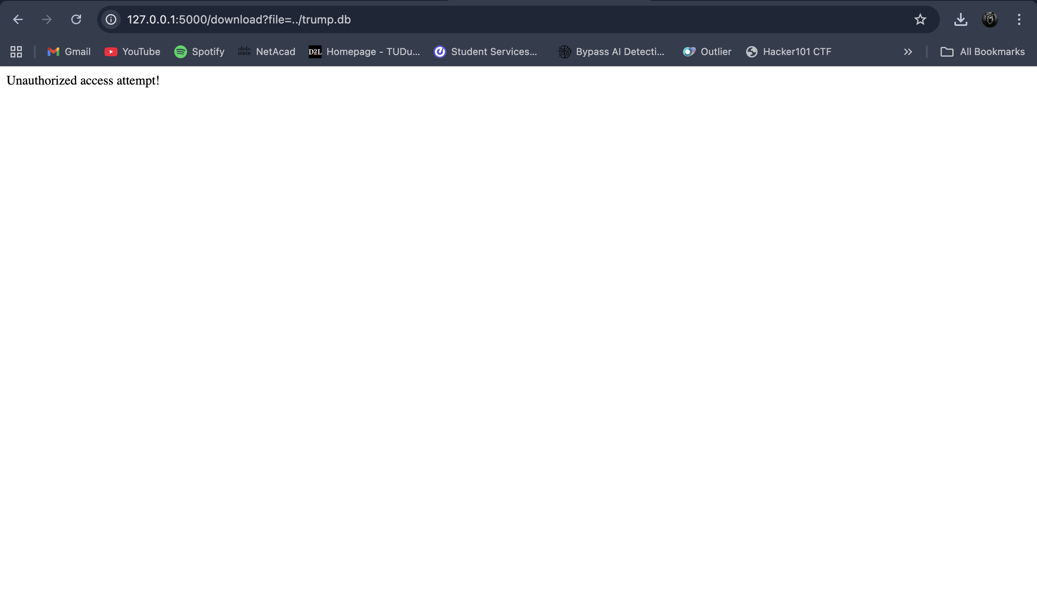

## Unknown Vulnerability:

## Exploit 3: IDOR

Insecure Direct Object Reference (IDOR) Vulnerability

Location: /profile/<user_id> route in app.py

The route accepts any user_id in the URL without authorisation checks There's no validation to ensure the logged-in user can only access their own profile. Any user can view any other user's profile by simply changing the ID in the URL

````

<http://127.0.0.1:5000/profile/3>

````

I was able to get personal information about a user named Colin using any profile/3 user_id.

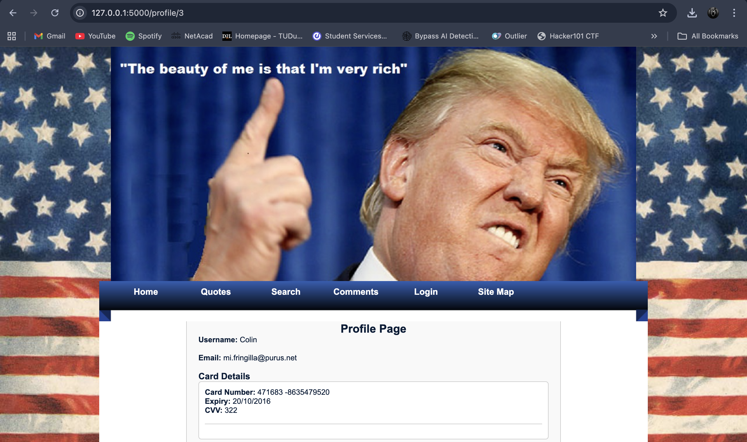

## Attack Scenario:

Attacker logs in as user ID 5 then changes URL from /profile/5 to /profile/1. Which then gives the attacker the ability to view user 1's profile and card details. Attacker then can enumerate all users and get their information

Fix:

Add authorisation to ensure users can only access their own profile:

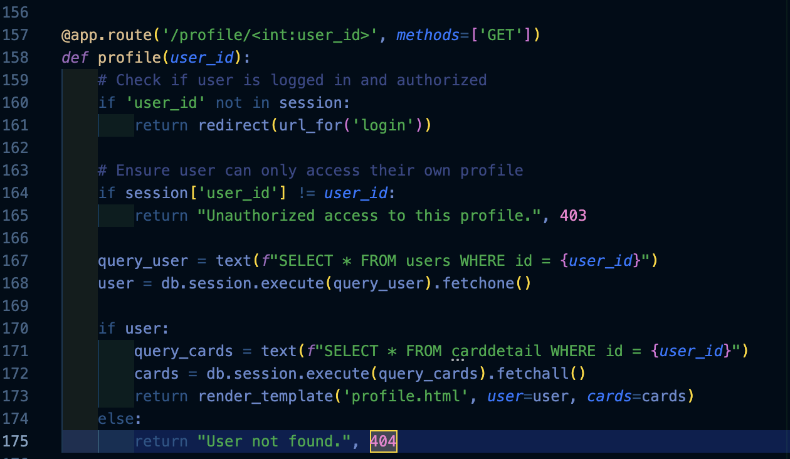

After the fix the ```http://127.0.0.1:5000/profile/1```` command redirects the user to the login page instead of showing the personal information of the user.

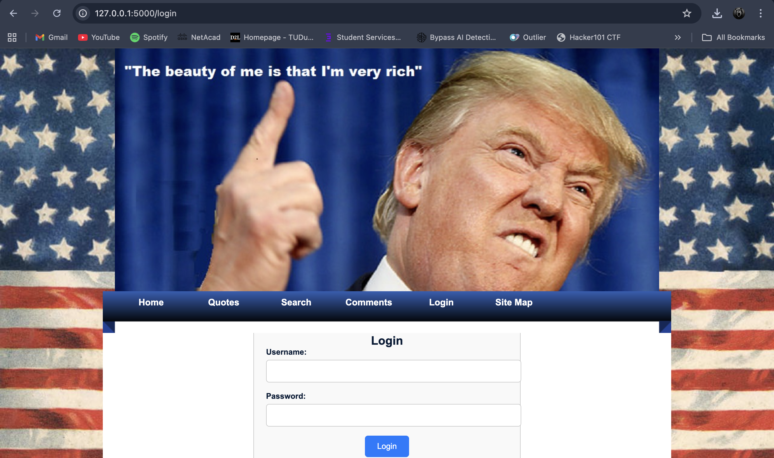

This is an Insecure Direct Object Reference (IDOR) vulnerability, which is a type of broken access control that allows unauthorised access to other users' data.

## Exploit 4: CSRF vulnerability

Cross-Site Request Forgery (CSRF) protection prevents attackers from tricking authenticated users into performing unwanted actions on a web application. The protection mechanism uses synchroniser tokens to verify that requests originate from legitimate forms.

## Force logout

The browser automatically includes session cookies with requests. The application has no way to verify the request originated from a legitimate form so it can forcefully log the user out of the website and redirect them back to the browser.

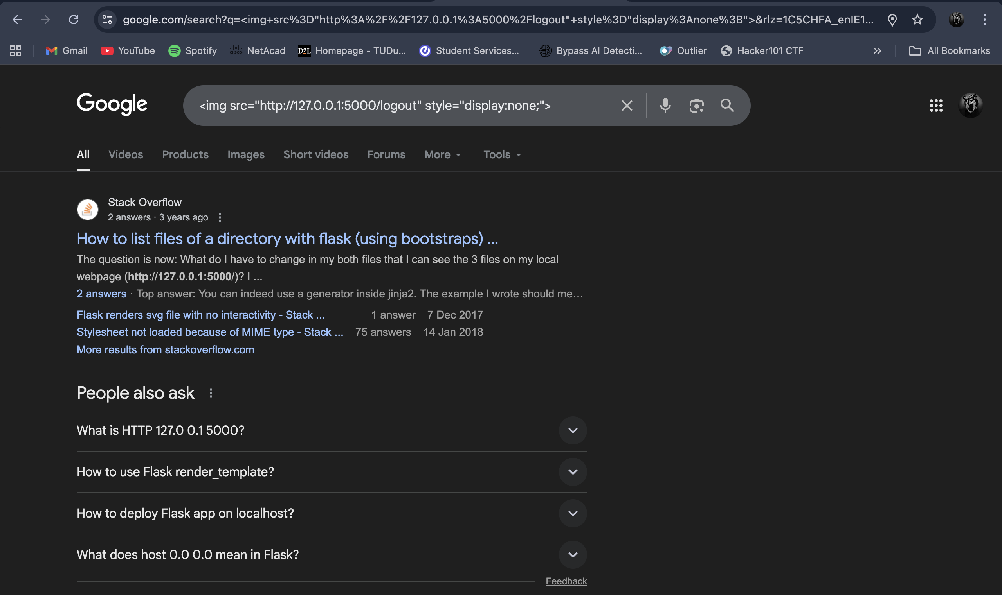

## The Issues:

**Location:** Multiple endpoints throughout the application

* /comments - Comment submission form
* /login - User authentication form
* /logout - Session termination endpoint

## Code vulnerabilities

* Issue 1: Vulnerable Code (app.py - Lines 1-11): Flask-WTF CSRF protection is not initialised, leaving all POST/PUT/DELETE endpoints vulnerable.
* Issue 2: Vulnerable Code (login.html - Line 9):  Forms lack hidden CSRF token fields, allowing forged requests to be accepted.

Fix: Install and configure Flask-WTF for CSRF protection and add the token.

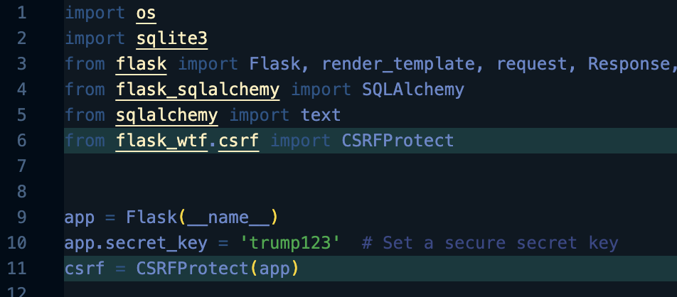

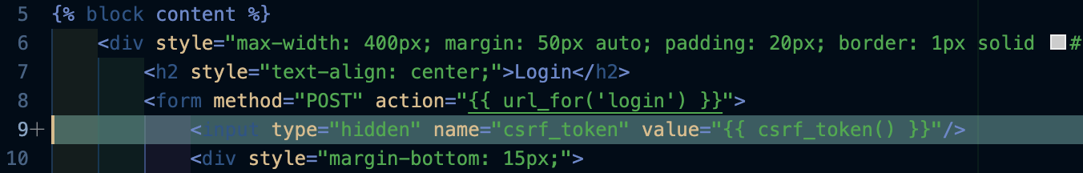

Malicious requests are now blocked. The request sends back an error and shoes `400 bad Request`` , which shows that CSRF is no longer a vulnerability.

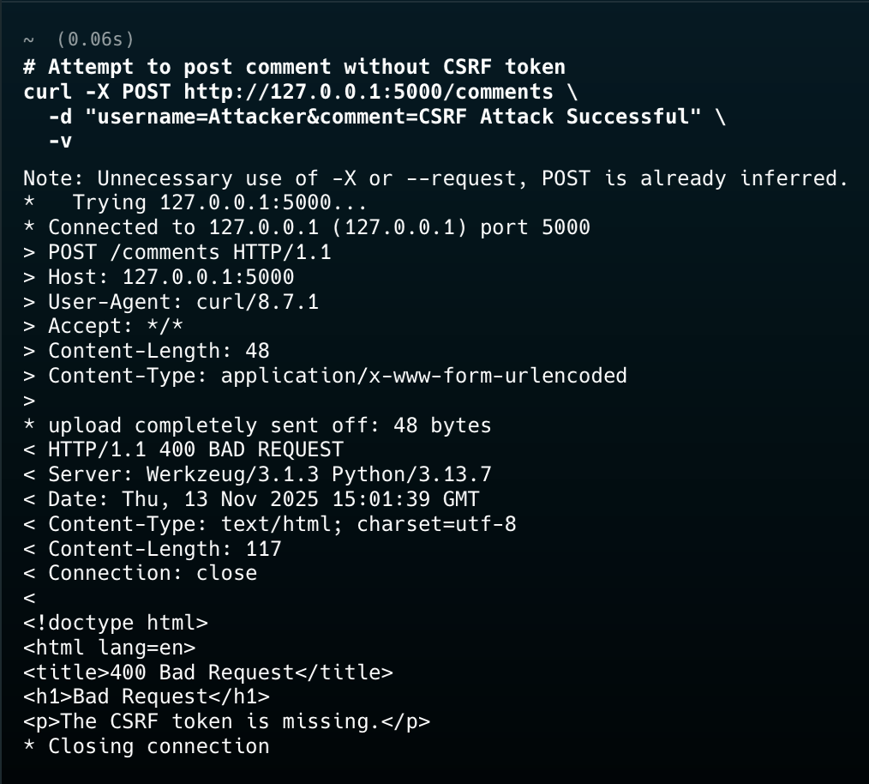

Malicious requests without CSRF tokens rejected with 400 error. Legitimate form submissions with valid tokens processed successfully. Force logout attack no longer functional

# References:

**OWASP CSRF Prevention Cheat Sheet:** <https://cheatsheetseries.owasp.org/cheatsheets/Cross-Site_Request_Forgery_Prevention_Cheat_Sheet.html>

**CWE-352: Cross-Site Request Forgery (CSRF):** <https://cwe.mitre.org/data/definitions/352.html>

**Flask-WTF Documentation:** <https://flask-wtf.readthedocs.io/>

**IDOR:** <https://medium.com/@varppi/explaining-and-exploiting-open-redirect-vulnerabilities-67dd825e2c49>